**PYTHON MINIPROJECT**

**TOPIC: Lending library**

BY

PARAS NANDWANI (ROLL NO: 39)

RITIK WADHWANI (ROLL NO: 69)

ROHAN ASRANI (ROLL NO: 02)

SAHIL SIDHANI (ROLL NO: 64)

**PROBLEM STATEMENT:**

To implement functionalities for lending, returning and it’s related functions for a library

**OBJECTIVE OF PROJECT:**

* To provide faculty and students with materials that enrich and support the curriculum and meet the needs of the students and faculty served.
* To provide students with a wide range of educational materials on all levels of difficulty and in a variety of formats, with diversity of appeal, allowing for the presentation of many different points of view.
* To select materials that present various sides of controversial issues, giving students an opportunity to develop analytical skills resulting in informed decisions.
* To select materials in all formats, including up-to-date, high quality, varied literature to develop and strengthen a love of reading.

**NEED FOR THE PROJECT:**

* The library system has many different tasks to perform in both the cases of librarian and student. This all is achieved by our single python-based application.
* To make the lending and returning process convenient for use.
* To create a consistent proper record of books, students and their lendings.

**Project workflow:**

**After Logout from Admin page we redirect to Main page**

**After Logout from Student page we redirect to Main page**

**Through Inheritance Main page will get features of Default page**

**DEFAULT PAGE**

**After login, Main page will be directed to Student page**

**After login, Main page will be directed to Admin page**

**STUDENT PAGE**

**ADMIN PAGE**

**MAIN PAGE**

**Admin Page Functions:**

* Check Pending Lends: After clicking on Check Pending Lends button, all the details of the pending lends will be displayed i.e. all the books which are not returned but just issued in a Simple Table Frame.
* Check Completed Lends: After clicking on Check Completed Lends button,the details of all the Completed Lends i.e. the books that are issued and returned by the students will be displayed in a format of Simple Table Frame.
* Check Available Books: After clicking on Check Available Books button, all the books in a library which are available i.e. where count of Available books>0 will be displayed in a Simple Table.
* See All Student Details: After clicking on See All Student Details button, all the students who are registered to Vesit library their details will be displayed.
* Add Books: The Add Books button is used to add new Book in a library, there 4 entries are to be done that is the Book Name, Author Name, Category and the Available Copies.
* Add Student: After clicking on Add Student button, new Student will be registered in the library.
* Logout: After clicking the LogOut button, which is at the top right of the AdminPage, we will be redirected to the MainPage.

**Student Page Functions:**

* The LOGOUT button redirects to the main page.
* On clicking issue button it calls **show_issue_details()** function which creates all semesters radio buttons and SHOW BOOKS button.
* SHOW BOOKS button calls **show_books** function, **show_books** function show the books of the selected semester.
* Student selects the book and click on ISSUE BOOK button or CHECK COPIES button.
* ISSUE BOOK button calls the **issue_book()** function which will get the selected book and checks for invalid cases.
* **let_student_issue()** function issues the selected book and decrease the count of book.
* **check_available_copies()** function shows the available copies of the selected book in the message box.
* On clicking PENDING BOOK button ,it will call the **book_status ()** function which will shows the pending books of the student.
* RETURN BOOK button calls the function **return_book()** function which will checks for invalid cases and calls **calculate_fine()** function and increase the book copy in the database.
* CHECK FINE button calls the **check_fine()** function which will check for invalid cases and returns the fine of student for the selected book.
* fine_message() function takes one parameter fine ad displays the fine in the messagebox.
* PREVIOUS BOOKSbutton will shows the previously lended books from the library by the student.

**CODE:**

PROJECT.sql:

USE project;

CREATE TABLE Admin

(

AdminId INT AUTO_INCREMENT PRIMARY KEY,

AName varchar(30),

Passwd VARCHAR(30)

);

CREATE TABLE Student

(

StudentId INT AUTO_INCREMENT PRIMARY KEY,

Passwd VARCHAR(30),

SName VARCHAR(30),

Class VARCHAR(7)

);

Alter table book add column AvailableCopies int default 5;

CREATE TABLE Book

(

BookId INT AUTO_INCREMENT PRIMARY KEY,

BName VARCHAR(300),

Author VARCHAR(30),

Category VARCHAR(30),

AvailableCopies int default 5

);

CREATE TABLE Lending

(

OrderId INT AUTO_INCREMENT PRIMARY KEY,

SId INT,

BId INT,

CONSTRAINT fk_category FOREIGN KEY (SId) REFERENCES Student(StudentId),

CONSTRAINT fk_categry FOREIGN KEY (BId) REFERENCES Book(BookId),

BDate DATE,

RDate DATE,

Fine INT,

IsReturned BOOLEAN DEFAULT 0

);

insert into Student(Passwd,SName,Class)

VALUES('bhavesh','Bhavesh','D10');

insert into Student(Passwd,SName,Class)

VALUES('jayesh','Jayesh','D10');

insert into Student(Passwd,SName,Class)

VALUES('dev','Dev','D5');

insert into Student(Passwd,SName,Class)

VALUES('hitesh','Hitesh','D10');

insert into Student(Passwd,SName,Class)

VALUES('megha','Megha','D20');

insert into Student(Passwd,SName,Class)

VALUES('rohit','Rohit','D15');

insert into Student(Passwd,SName,Class)

VALUES('dharkan','Dharkan','D10');

insert into Student(Passwd,SName,Class)

VALUES('dinesh','Dinesh','D10');

insert into Student(Passwd,SName,Class)

VALUES('dhiraj','Dhiraj','D10');

insert into Student(Passwd,SName,Class)

VALUES('ravishankar','Ravishankar','D20');

insert into Book(BName,Author,Category) values('Engineering Mechanics','Prof.M.D. Dayal','SEM-I');

insert into Book(BName,Author,Category) values('Basic Electrical & Electronics Engineering','Ravish Singh','SEM-I');

insert into Book(BName,Author,Category) values('Applied Mathematics 1','Prof.G.V. Kumbhojkar','SEM-I');

insert into Book(BName,Author,Category) values('Applied Physics 1','Dr. I.A.Shaikh(Techmax)','SEM-I');

insert into Book(BName,Author,Category) values('Applied Chemistry','Prof. Keni Sir','SEM-I');

insert into Book(BName,Author,Category) values('Environmental Studies','Parikh J.A','SEM-I');

insert into Book(BName,Author,Category) values('Engineering Drawing','N.H.Dubey','SEM-II');

insert into Book(BName,Author,Category) values('Structured Programming Approach','Prof.Makrand Sir','SEM-II');

insert into Book(BName,Author,Category) values('Applied Mathematics 2','Prof.G.V. Kumbhojkar','SEM-II');

insert into Book(BName,Author,Category) values('Applied Physics 2','Prof. Keni Sir','SEM-II');

insert into Book(BName,Author,Category) values('Applied Chemistry','Prof.V.M. Balsaraf','SEM-II');

insert into Book(BName,Author,Category) values('Communication Skills','Sanyukta Shah Neb','SEM-II');

insert into Book(BName,Author,Category) values('Applied Mathematics 3','Prof.G.V. Kumbhojkar','SEM-III');

insert into Book(BName,Author,Category) values('Data Structure & Algorithm Analysis','Ellis horowitz','SEM-III');

insert into Book(BName,Author,Category) values('Object Oriented Programming Methodology','James Rumbaugh','SEM-III');

insert into Book(BName,Author,Category) values('Logic Design','Anil K. Mani','SEM-III');

insert into Book(BName,Author,Category) values('Database Management System','Korth','SEM-III');

insert into Book(BName,Author,Category) values('Principles of Communication','McGraw Hill','SEM-III');

insert into Book(BName,Author,Category) values('Applied Mathematics 4','Prof.G.V. Kumbhojkar','SEM-IV');

insert into Book(BName,Author,Category) values('Computer Networks','Peterson & Davie','SEM-IV');

insert into Book(BName,Author,Category) values('Computer Organization & Architecture','William Stallings','SEM-IV');

insert into Book(BName,Author,Category) values('Automata Theory','Michael Sipser','SEM-IV');

insert into Book(BName,Author,Category) values('Operating Systom','Vivek V. Jog','SEM-IV');

insert into Book(BName,Author,Category) values('Python','Nageshwar Rao','SEM-IV');

insert into Book(BName,Author,Category) values('Computer Graphics & Virtual Reality','R.K. Maurya','SEM-V');

insert into Book(BName,Author,Category) values('Operating System','Achyut S. Godbole','SEM-V');

insert into Book(BName,Author,Category) values('Microcontroller & Embedded System','Shibu K.V McGraw','SEM-V');

insert into Book(BName,Author,Category) values('Advanced Database Management Systems','Elmasri and Navathe','SEM-V');

insert into Book(BName,Author,Category) values('Open Source Technologies','Ambavade-Dreamtech','SEM-V');

insert into Book(BName,Author,Category) values('Business Communication & Ethics','Dr. K.Alex','SEM-V');

insert into Book(BName,Author,Category) values('Software Engineering','Ian Sommerville','SEM-VI');

insert into Book(BName,Author,Category) values('Distributed System','Andrew S. & Marteen Steen','SEM-VI');

insert into Book(BName,Author,Category) values('System & Web Security','William Stallings','SEM-VI');

insert into Book(BName,Author,Category) values('Data Mining & Business Intelligance','G. Shmueli','SEM-VI');

insert into Book(BName,Author,Category) values('Advanced Internet Technology','WROX press','SEM-VI');

insert into Book(BName,Author,Category) values('Software Project Management','Hughes & Cornell','SEM-VII');

insert into Book(BName,Author,Category) values('Cloud Computing','Rajkumar B. Wiley','SEM-VII');

insert into Book(BName,Author,Category) values('Intelligent System','Stuart Rusell % Peter N','SEM-VII');

insert into Book(BName,Author,Category) values('Wireless Technology','Vijay K.Garg','SEM-VII');

insert into Book(BName,Author,Category) values('Image Processing','S.Shridhar','SEM-VII');

insert into Book(BName,Author,Category) values('Software Architecture','M.Shaw','SEM-VII');

insert into Book(BName,Author,Category) values('E-commerece & E-business','Henry Chan','SEM-VII');

insert into Book(BName,Author,Category) values('Storage Network Management & Retrieval','Robert Spalding','SEM-VIII');

insert into Book(BName,Author,Category) values('Big Data Analytics','Bill Franks','SEM-VIII');

insert into Book(BName,Author,Category) values('Computer Simulation & Modelling','Averill M.Law','SEM-VIII');

insert into Book(BName,Author,Category) values('Enterprice Resource Planning','Alex Leon','SEM-VIII');

insert into Book(BName,Author,Category) values('Wireless Sensor Networks','Edghar H.','SEM-VIII');

insert into Book(BName,Author,Category) values('Geographical Inforamtion Systems','M.N.DeMers','SEM-VIII');

insert into Admin(AName,Passwd) values('Ritik','ritik');

insert into Admin(AName,Passwd) values('Sahil','sahil');

insert into Admin(AName,Passwd) values('Paras','paras');

insert into Admin(AName,Passwd) values('Rohan','rohan');

select * from Admin;

select * from Student;

select * from Book;

insert into Lending(SId ,BId,BDate) Values(2,2,'2020-04-11');

insert into Lending(SId ,BId,BDate) Values(4,9,'2020-04-12');

insert into Lending(SId ,BId,BDate) Values(6,12,'2020-04-12');

insert into project.lending(SId,BId,BDate,RDate,isReturned) values(3,7,'2020-04-10','2020-04-13',1);

insert into project.lending(SId,BId,BDate,RDate,isReturned) values(8,5,'2020-04-10','2020-04-13',1);

select * from lending;

**ADMIN TABLE:**

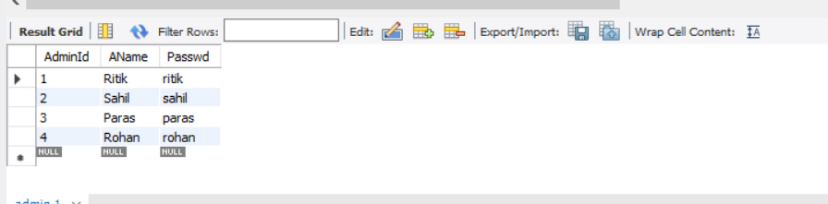

**STUDENT TABLE:**

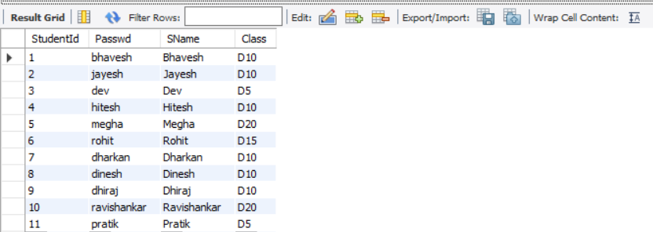

**BOOK TABLE:**

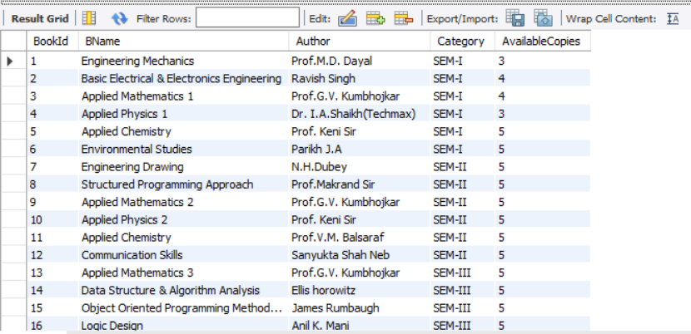

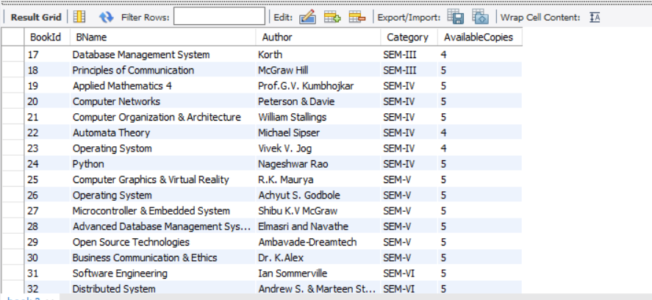

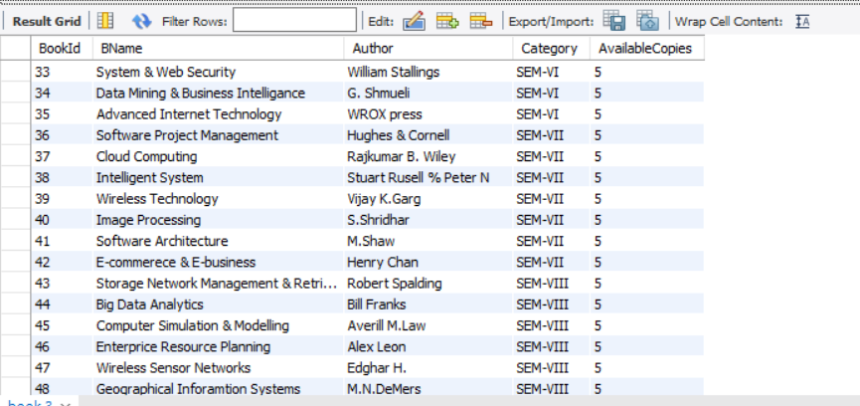

**LENDING TABLE:**

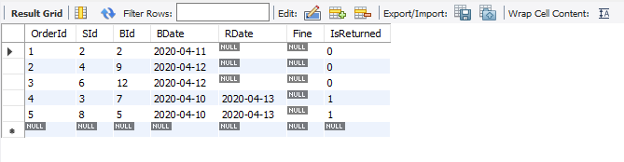

DefaultPage.py:

from tkinter import *

from PIL import Image,ImageTk

from pymysql import *

class DefaultPage:

def __init__(self,root):

self.root=root

self.root.title('VESIT Library')

self.root.iconbitmap('images/project_icon_pic.ico')

self.f=Frame(root,width=1600,height=900)# 900x500 in mainpage

self.f.pack()

# The footer at the bottom

self.footer = Label(self.f, bg="ivory3", height=1, text="@VES Institute of Technology, Since 1962")

self.footer.pack(side=BOTTOM, fill=X)

self.b_image = Image.open("images/lib-background-img.jpg")

self.b_image = self.b_image.resize((1600, 900))

self.img = ImageTk.PhotoImage(self.b_image)

self.panel = Label(self.f, image=self.img)

self.panel.pack()

self.panel.pack_propagate(0)

self.img1=Image.open("images/Importance-of-Books.jpg")

self.img1=self.img1.resize((100, 48))

self.img_1 = ImageTk.PhotoImage(self.img1)

self.p1=Label(self.f,image=self.img_1,borderwidth=2,relief=SOLID)

self.p1.place(x=40,y=20)

self.img2 = Image.open("images/You_can_read.jpg")

self.img2 = self.img2.resize((70, 100))

self.img_2 = ImageTk.PhotoImage(self.img2)

self.p2 = Label(self.f, image=self.img_2, borderwidth=2, relief=SOLID)

self.p2.place(x=30, y=600)

self.m = Message(self.f, width=600, font=("Mongolian Baiti", 25, "bold"), text="VESIT LIBRARY", bg="white",

relief=SOLID, borderwidth=2)

self.m.place(x=144, y=20)

self.f.pack_propagate(0)

class LoginButton(Button):

def __init__(self, parent, text, command, **kwargs):

super().__init__(parent, text=text, width=30, height=3, bg='#f3f5cb', activebackground="white",

activeforeground="white", command=command)

self.configure(**kwargs)

class CreamButton(Button):

def __init__(self, parent, text, command, **kwargs):

super().__init__(parent, text=text, width=25, height=2, font="Algerian 13 bold", bg="#FFDBAC", fg="black",

activebackground="gray", command=command)

self.configure(**kwargs)

class ScrolledFrame:

def __init__(self, master, **kwargs):

width = kwargs.pop('width', None)

height = kwargs.pop('height', None)

self.outer = Frame(master, **kwargs)

self.vsb = Scrollbar(self.outer, orient=VERTICAL)

self.vsb.pack(fill=Y, side=RIGHT)

self.canvas = Canvas(self.outer, highlightthickness=0, width=width, height=height)

self.canvas.pack(side=LEFT, fill=BOTH, expand=True)

self.canvas['yscrollcommand'] = self.vsb.set

self.canvas.bind("<Enter>", self._bind_mouse)

self.canvas.bind("<Leave>", self._unbind_mouse)

self.vsb['command'] = self.canvas.yview

self.inner = Frame(self.canvas)

self.canvas.create_window(4, 4, window=self.inner, anchor='nw')

self.inner.bind("<Configure>", self._on_frame_configure)

self.outer_attr = set(dir(Widget))

def __getattr__(self, item):

if item in self.outer_attr:

return getattr(self.outer, item)

else:

return getattr(self.inner, item)

def _on_frame_configure(self, event=None):

x1, y1, x2, y2 = self.canvas.bbox("all")

height = self.canvas.winfo_height()

self.canvas.config(scrollregion=(0, 0, x2, max(y2, height)))

def _bind_mouse(self, event=None):

self.canvas.bind_all("<4>", self._on_mousewheel)

self.canvas.bind_all("<5>", self._on_mousewheel)

self.canvas.bind_all("<MouseWheel>", self._on_mousewheel)

def _unbind_mouse(self, event=None):

self.canvas.unbind_all("<4>")

self.canvas.unbind_all("<5>")

self.canvas.unbind_all("<MouseWheel>")

def _on_mousewheel(self, event):

if event.num == 4 or event.delta > 0:

self.canvas.yview_scroll(-1, "units")

elif event.num == 5 or event.delta < 0:

self.canvas.yview_scroll(1, "units")

class SimpleTable(ScrolledFrame):

def __init__(self, parent, rows=10, columns=5, colour=None, **kwargs):

super().__init__(parent, background="#f2efe6", **kwargs)

self.header_color = colour

self.even_color = colour

self.odd_color = colour

# f2dba0#f06787#bbdbab

self._widgets = []

for row in range(rows):

current_row = []

if (row == 0):

bg = self.header_color

elif (row % 2 == 0):

bg = self.even_color

else:

bg = self.odd_color

for column in range(columns):

label = Label(self, text="-", borderwidth=0, height=3, bg=bg, wraplength=400)

label.grid(row=row, column=column, sticky="nsew", padx=1, pady=1)

current_row.append(label)

self._widgets.append(current_row)

for column in range(columns):

self.grid_columnconfigure(column, weight=1)

def set(self, row, column, value, widget=None, **kwargs):

widget_ref = self._widgets[row][column]

if (widget is not None):

if (row % 2 == 0):

widget.configure(bg=self.even_color)

else:

widget.configure(bg=self.odd_color)

widget.grid(row=row, column=column, sticky="nsew", padx=1, pady=1)

self._widgets[row][column] = widget

widget_ref = widget

widget_ref.configure(text=str(value), **kwargs)

class DatabaseHelper():

@staticmethod

def get_columns(description):

return tuple(map(lambda x: x[0], description))

@staticmethod

def get_data(query, parameters=None):

conn = connect(host='localhost', database='project', user='root', password='Ra4@246890')

cur = conn.cursor()

if parameters is None:

cur.execute(query)

else:

cur.execute(query % parameters)

result = cur.fetchone()

cur.close()

conn.close()

return result

@staticmethod

def get_all_data(query, parameters=None):

conn = connect(host='localhost', database='project', user='root', password='Ra4@246890')

cur = conn.cursor()

if (parameters is None):

cur.execute(query)

else:

cur.execute(query % parameters)

result = cur.fetchall()

headers = DefaultPage.DatabaseHelper.get_columns(cur.description)

cur.close()

conn.close()

return (headers,) + result

@staticmethod

def execute_query(query, parameters=None):

conn = connect(host='localhost', database='project', user='root', password='Ra4@246890')

cur = conn.cursor()

if parameters is None:

cur.execute(query)

else:

cur.execute(query % parameters)

conn.commit()

cur.close()

conn.close()

if __name__=="__main__":

root=Tk()

d=DefaultPage(root)

root.mainloop()

**OUTPUT:**

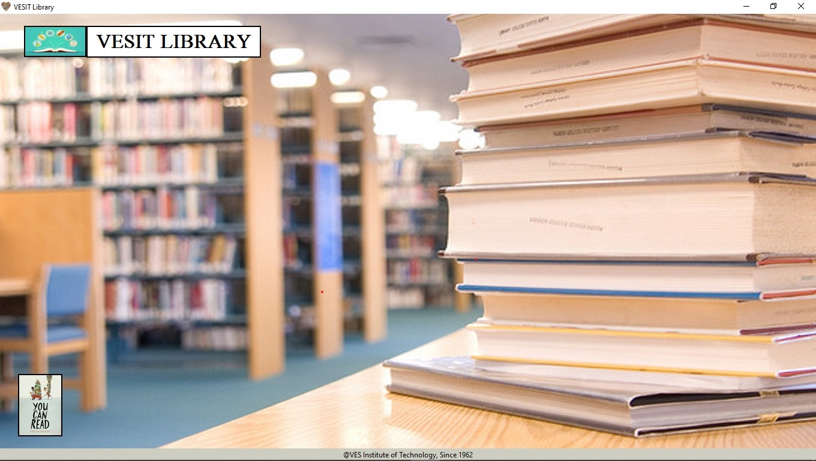

MainPage.py:

from AdminPage import *

from StudentPage import *

class MainPage(DefaultPage):

def __init__(self,root):

super().__init__(root)

self.root.geometry('900x550')

self.root.state('normal')

self.add_widgets()

def add_widgets(self):

self.admin_button = DefaultPage.LoginButton(self.panel, "Admin login" ,lambda: self.getLoginScreen("Admin"),relief='raised',borderwidth=4,)

self.admin_button.place(x=210, y=220)

self.user_button = DefaultPage.LoginButton(self.panel, "Student login", lambda: self.getLoginScreen("User"),relief='raised',borderwidth=4)

self.user_button.place(x=500, y=220)

def reset(self):

self.e_username.delete(0,END)

self.e_password.delete(0, END)

def getLoginScreen(self,login_type):

login_window = Toplevel()

login_window.title(login_type)

f = Frame(login_window, height=200, width=400,bg="gold")

l1 = Label(f, width=20, text="Enter username: ")

self.e_username = Entry(f, width=30, fg='black', bg='white')

self.e_username.focus_set()

self.e_password = Entry(f, width=30, fg='black', bg='white', show='*')

l2 = Label(f, width=20, text="Enter password: ")

l1.grid(row=1, column=1, padx=10, pady=10)

l2.grid(row=2, column=1, padx=10, pady=10)

self.e_username.grid(row=1, column=4, padx=10, pady=10)

self.e_password.grid(row=2, column=4, padx=10, pady=10)

b1 = Button(f, text="Submit", height=2, width=10,command=lambda: self.validate(login_window, login_type))

b1.grid(row=3, column=1, padx=10, sticky='e')

b2 = Button(f, text="Reset", height=2, width=10, command=lambda: self.reset())

b2.grid(row=3, column=4, padx=10, sticky='w')

f.pack()

f.grid_propagate(0)

def validate(self,login_window,login_type):

username=self.e_username.get()

pwd = self.e_password.get()

if login_type=="Admin":

query = "Select * from project.Admin where AName= '%s' and Passwd='%s'"

else:

query = "Select * from project.Student where SName= '%s' and Passwd='%s'"

parameters=(username,pwd)

result = DefaultPage.DatabaseHelper.get_data(query,parameters)

if result is None or len(result)==0 :

messagebox.showerror("Login Failed","Incorrect credentials")

else:

messagebox.showinfo('Login Success',"Login successfuly completed")

login_window.destroy()

self.f.destroy()

self.panel.destroy()

if login_type=="Admin":

self.redirect=AdminHomePage(self.root, result)

else:

self.redirect=StudentPage(self.root,result)

if __name__=="__main__":

root=Tk()

m=MainPage(root)

root.mainloop()

**OUTPUT:**

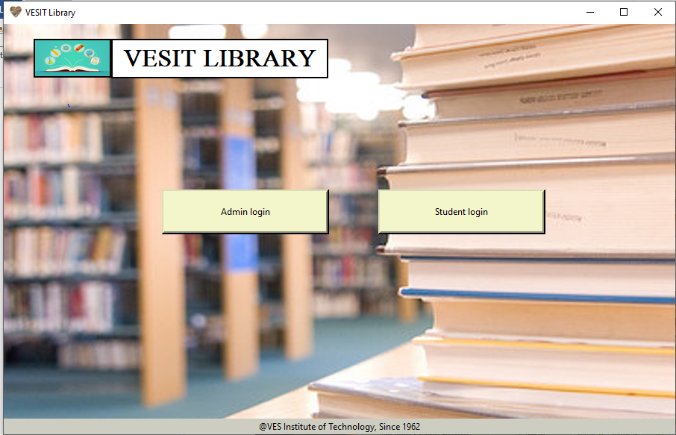

**ADMIN LOGIN:**

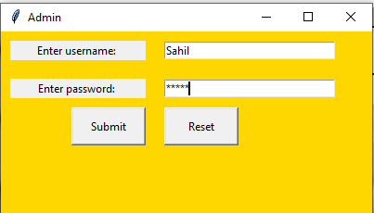

On clicking **SUBMIT** button:

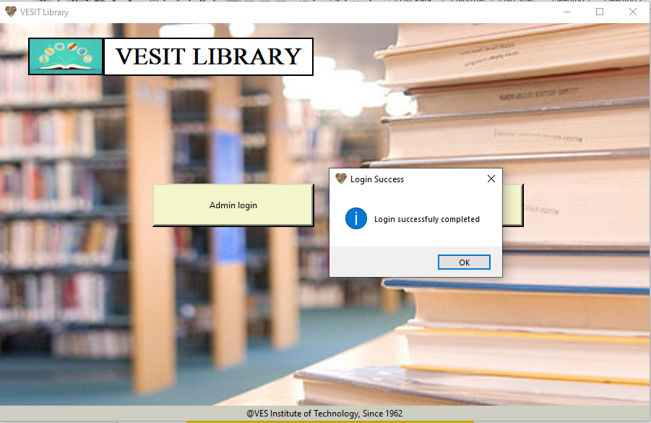

**STUDENT LOGIN:**

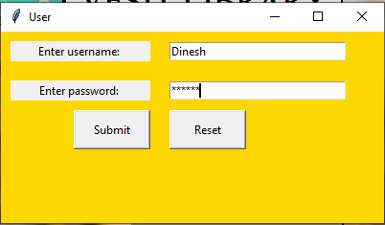

On clicking **SUBMIT** button:



AdminPage.py:

from tkinter import messagebox

from DefaultPage import *

class AdminHomePage(DefaultPage):

def __init__(self,root,admin_details):

super().__init__(root)

self.root.state('zoomed')

self.details=admin_details

self.dct_IntVar={}

self.m = Message(self.panel, width=850, font=("Bernard MT Condensed",25,"bold underline"),text=f"Welcome {self.details[1]}", bg="#b5caeb", relief=SOLID, borderwidth=2)

self.m.place(x=50, y=100)

self.add_buttons()

def add_buttons(self):

self.pending_button = DefaultPage.CreamButton(self.f, "CHECK PENDING LENDS", self.view_pending_lends)

self.pending_button.place(x=50, y=250)

self.check_completed_button = DefaultPage.CreamButton(self.f, "CHECK COMPLETED LENDS", self.check_completed_lends)

self.check_completed_button.place(x=50, y=325)

self.addStud = DefaultPage.CreamButton(self.f, "ADD STUDENT", self.signup_form, bg='#d1a924')

self.addStud.place(x=900, y=175)

self.addBk = DefaultPage.CreamButton(self.f, "ADD BOOKS", self.add_books, bg='#d1a924')

self.addBk.place(x=500, y=175)

self.seeBooks = DefaultPage.CreamButton(self.f,"CHECK AVAILABLE BOOKS",self.see_books)

self.seeBooks.place(x=50,y=400)

self.seeStudents = DefaultPage.CreamButton(self.f,"SEE ALL STUDENT DETAILS",self.see_students)

self.seeStudents.place(x=50,y=475)

self.logout = DefaultPage.CreamButton(self.f, "LOGOUT", self.admin_logout, width=10)

self.logout.place(x=1200, y=20)

def view_pending_lends(self):

query = """select l.OrderId,s.StudentId,s.SName,b.BName,b.Author,b.Category,l.BDate

from student s

join lending l

join book b

on b.BookId=l.BId

on s.StudentId=l.SId

where l.IsReturned=0;"""

result = DefaultPage.DatabaseHelper.get_all_data(query)

self.menu_frame = DefaultPage.SimpleTable(self.f, rows=len(result), columns=len(result[0]), height=450, width=680,colour="#f06787")

self.menu_frame.place(x=500, y=250)

self.menu_frame.grid_propagate(0)

for i in range(1, len(result)):

self.dct_IntVar[result[i][0]] = IntVar()

for i in range(len(result)):

for j in range(len(result[0])):

if i == 0:

self.menu_frame.set(row=i, column=j, value=result[i][j], bg="#c9083f", fg="white")

elif j == 0 and i != 0:

self.menu_frame.set(row=i, column=j, value=result[i][j])

elif j == 2 :

self.menu_frame.set(row=i, column=j, value=result[i][j], width=12)

elif j == 3 :

self.menu_frame.set(row=i, column=j, value=result[i][j], width=32)

elif j == 4 :

self.menu_frame.set(row=i, column=j, value=result[i][j], width=18)

elif j == 6 :

self.menu_frame.set(row=i, column=j, value=result[i][j], width=12)

else:

self.menu_frame.set(row=i, column=j, value=result[i][j])

def check_completed_lends(self):

query = """select l.OrderId,l.SId,s.SName,b.BName,b.Author,l.BDate,l.Fine

from book b join student s join lending l

on s.StudentId=l.SId

on b.BookId=l.BId

where l.IsReturned=1;"""

result = DefaultPage.DatabaseHelper.get_all_data(query)

self.menu_completed_lends = DefaultPage.SimpleTable(self.f, rows=len(result), columns=len(result[0]), height=450,

width=680,colour="#bbdbab")

self.menu_completed_lends.place(x=500, y=250)

self.menu_completed_lends.grid_propagate(0)

for i in range(len(result)):

for j in range(len(result[0])):

if i == 0:

self.menu_completed_lends.set(row=i, column=j, value=result[i][j], bg="#0aa80c", fg="white")

elif j == 0 and i != 0:

self.menu_completed_lends.set(row=i, column=j, value=result[i][j])

elif j == 2:

self.menu_completed_lends.set(row=i, column=j, value=result[i][j], width=12)

elif j == 3:

self.menu_completed_lends.set(row=i, column=j, value=result[i][j], width=32)

elif j == 4:

self.menu_completed_lends.set(row=i, column=j, value=result[i][j], width=18)

elif j == 5:

self.menu_completed_lends.set(row=i, column=j, value=result[i][j], width=12)

elif j == 6:

self.menu_completed_lends.set(row=i, column=j, value=result[i][j], width=12)

else:

self.menu_completed_lends.set(row=i, column=j, value=result[i][j])

def signup_form(self):

student_signup = Toplevel()

student_signup.title('Sign-up')

f = Frame(student_signup, height=250, width=400, bg="gold")

l1 = Label(f, width=20, text="Enter Student name: ")

l2 = Label(f, width=20, text="Enter Class: ")

l3 = Label(f, width=20, text="Enter password: ")

l4 = Label(f, width=50,text="Enter the details below to add a Student",bg="black",fg="white")

self.e_studname = Entry(f, width=30, fg='black', bg='white')

self.e_studname.focus_set()

self.e_class = Entry(f, width=30, fg='black', bg='white')

self.e_password = Entry(f, width=30, fg='black', bg='white', show='*')

l1.grid(row=2, column=1, padx=10, pady=10)

l2.grid(row=3, column=1, padx=10, pady=10)

l3.grid(row=4, column=1, padx=10, pady=10)

l4.grid(row=1, column=0, columnspan=3, padx=10, pady=10)

self.e_studname.grid(row=2, column=2, padx=10, pady=10)

self.e_password.grid(row=4, column=2, padx=10, pady=10)

self.e_class.grid(row=3, column=2, padx=10, pady=10)

b1 = Button(f, text="Submit", height=2, width=10, command=lambda: self.add_student(student_signup))

b1.grid(row=5, column=2, padx=10, sticky='w')

f.pack()

f.grid_propagate(0)

def add_student(self,top_level):

name = self.e_studname.get()

password = self.e_password.get()

class_ = self.e_class.get()

if self.e_studname.get() == '' or self.e_password.get() == '' or self.e_class.get() == '':

messagebox.showwarning('Incomplete Data','Please Enter all the details')

else:

params=(password,name,class_)

query="insert into project.student(Passwd,SName,Class) values('%s','%s','%s')"

DefaultPage.DatabaseHelper.execute_query(query,params)

messagebox.showinfo('New Student Registration',"Student Registered successfully")

top_level.destroy()

def add_books(self):

login_window1 = Toplevel()

login_window1.title('Book')

f2 = Frame(login_window1, height=260, width=400, bg='gold')

lab = Label(f2, width=50, text="Enter below details to add book", bg="black", fg="white")

lab.grid(row=1, column=0, columnspan=3, padx=10, pady=10)

Bname = Label(f2, width=20, text="Enter Bookname: ")

self.e_Bname = Entry(f2, width=30, fg='black', bg='white')

self.e_Authorname = Entry(f2, width=30, fg='black', bg='white')

Authorname = Label(f2, width=20, text="Enter Author Name: ")

Category = Label(f2, width=20, text="Enter Category: ")

self.e_Category = Entry(f2, width=30, fg='black', bg='white')

Bname.grid(row=2, column=1, padx=10, pady=10)

self.e_Bname.grid(row=2, column=2, padx=10, pady=10)

self.e_Authorname.grid(row=3, column=2, padx=10, pady=10)

Authorname.grid(row=3, column=1, padx=10, pady=10)

Category.grid(row=4, column=1, padx=10, pady=10)

self.e_Category.grid(row=4, column=2, padx=10, pady=10)

No_of_copies = Label(f2, width=20, text="Enter Available Copies ")

self.e_Availablecopies = Entry(f2, width=30, fg='black', bg='white')

No_of_copies.grid(row=5, column=1, padx=10, pady=10)

self.e_Availablecopies.grid(row=5, column=2, padx=10, pady=10)

b1 = Button(f2, text="Add book", height=2, width=10, command=lambda: self.Newbk(login_window1))

b1.grid(row=6, column=2, columnspan=1, padx=10, sticky=W)

f2.pack()

f2.grid_propagate(0)

def Newbk(self,top_level):

bName = self.e_Bname.get()

Author = self.e_Authorname.get()

category = self.e_Category.get()

copies = self.e_Availablecopies.get()

if self.e_Bname.get() == '' or self.e_Authorname.get() == '' or self.e_Category.get() == '' or self.e_Availablecopies.get() == '':

messagebox.showwarning('Incomplete Data', 'Please Enter all the details')

else:

params = (bName, Author, category, copies)

query = "Insert into project.book(BName,Author,Category, AvailableCopies) Values('%s','%s','%s', '%s')"

DefaultPage.DatabaseHelper.execute_query(query, params)

messagebox.showinfo('New Book Entry', 'Book added Successfully')

top_level.destroy()

def see_books(self):

query = """select * from project.book

where AvailableCopies>0;"""

result = DefaultPage.DatabaseHelper.get_all_data(query)

self.menu_frame = DefaultPage.SimpleTable(self.f, rows=len(result), columns=len(result[0]), height=450,

width=680, colour="#bbdbab")

self.menu_frame.place(x=500, y=250)

self.menu_frame.grid_propagate(0)

for i in range(len(result)):

for j in range(len(result[0])):

if i == 0:

self.menu_frame.set(row=i, column=j, value=result[i][j], bg="#0aa80c", fg="white")

elif j == 0:

self.menu_frame.set(row=i, column=j, value=result[i][j], width=14)

elif j == 3:

self.menu_frame.set(row=i, column=j, value=result[i][j], width=12)

elif j == 4:

self.menu_frame.set(row=i, column=j, value=result[i][j], width=14)

else:

self.menu_frame.set(row=i, column=j, value=result[i][j])

def see_students(self):

query = """select StudentId,SName,Class from Student"""

result = DefaultPage.DatabaseHelper.get_all_data(query)

self.student_details_table = DefaultPage.SimpleTable(self.f, rows=len(result), columns=len(result[0]), height=450,

width=680, colour="#bbdbab")

self.student_details_table.place(x=500, y=250)

self.student_details_table.grid_propagate(0)

for i in range(len(result)):

for j in range(len(result[0])):

if i == 0:

self.student_details_table.set(row=i, column=j, value=result[i][j], bg="#0aa80c", fg="white")

elif j == 0 :

self.student_details_table.set(row=i, column=j, value=result[i][j], width=30)

elif j == 1:

self.student_details_table.set(row=i, column=j, value=result[i][j], width=35)

elif j == 2:

self.student_details_table.set(row=i, column=j, value=result[i][j], width=30)

else:

self.student_details_table.set(row=i, column=j, value=result[i][j])

def admin_logout(self):

import MainPage

self.f.destroy()

self.panel.destroy()

self.redirect=MainPage.MainPage(self.root)

if(__name__=="__main__"):

root=Tk()

admin_details=(4,'Rohan','rohan')

a=AdminHomePage(root,admin_details)

root.mainloop()

**OUTPUT:**

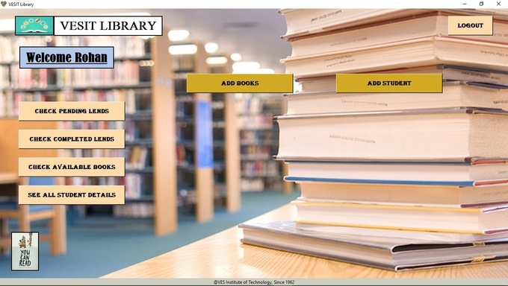

On clicking **CHECK PENDING LENDS** button, Admin/Librarian can see the pending books of students

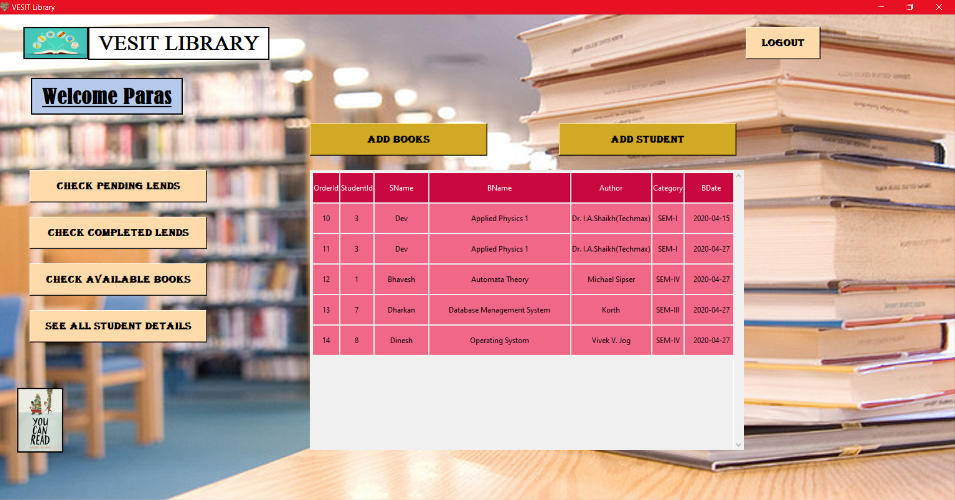

On clicking **CHECK COMPLETED LENDS** button, Admin/Librarian can see the returned books of students

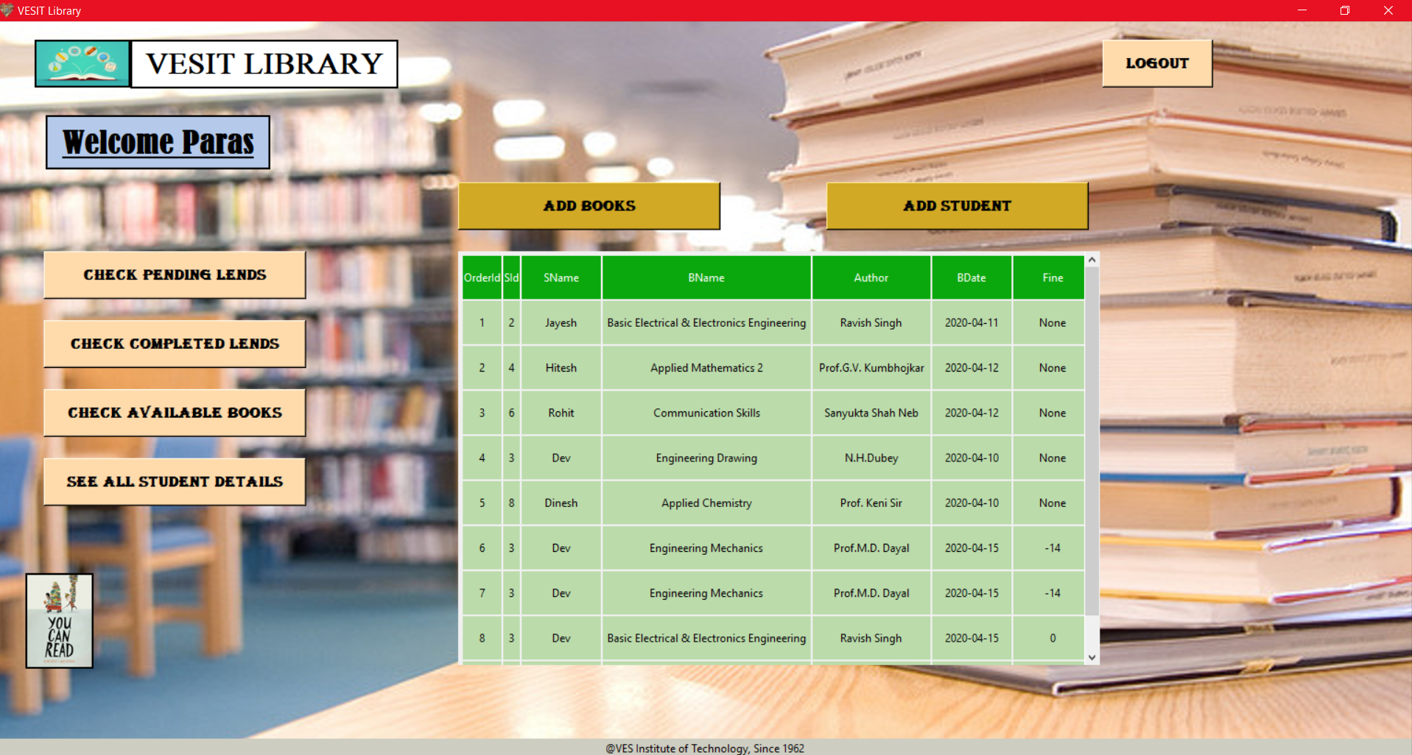

Admin has authority to check books and students.

On clicking **CHECK AVAILABLE BOOKS** Admin will see the list of all the available books currently present in library

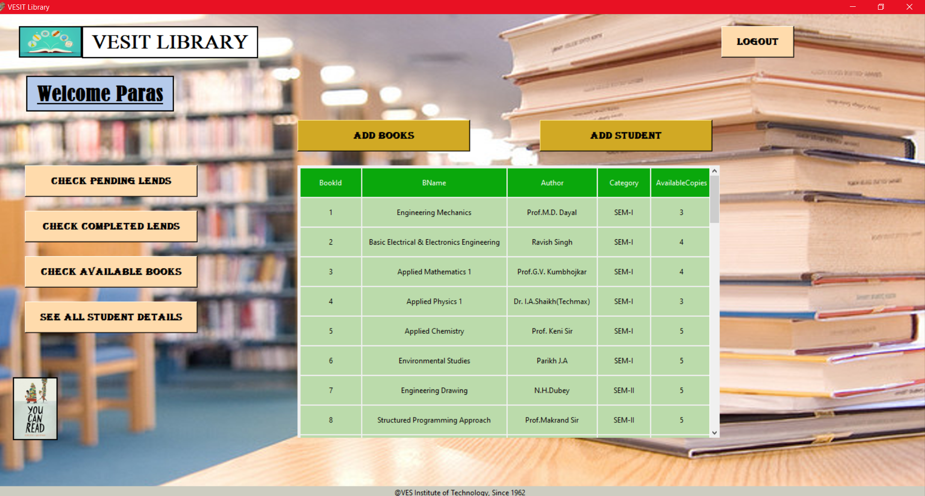

On clicking **SEE ALL STUDENT DETAILS** Admin will see the list of all the students

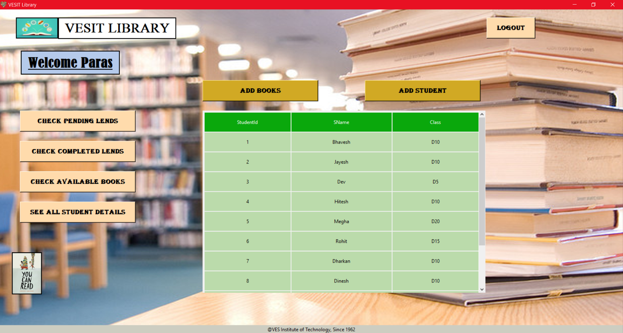

Admin can also add books and student.

So, on clicking the **ADD BOOKS** button a form will appear in which admin enters the details of the book which is going to be added

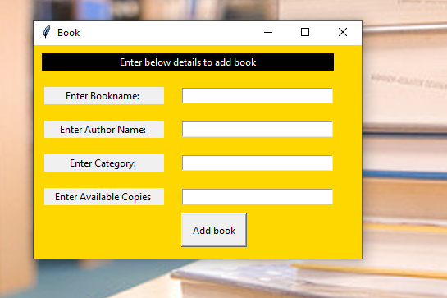

After filling details and clicking on **Add Book,** the book is registered in database

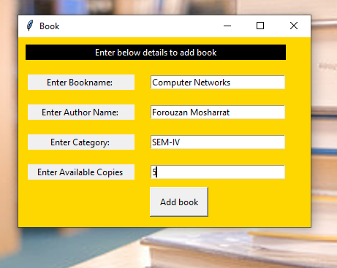



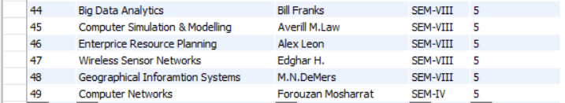

On clicking the **ADD STUDENT** button a form will appear in which admin enters the details of the book which is going to be added

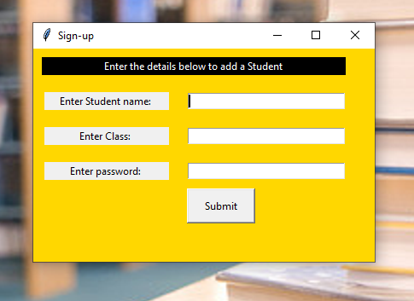

After filling details and clicking on **Add Student,** the book is registered in database

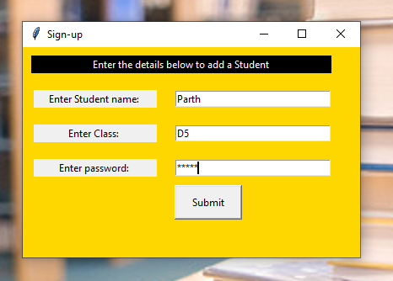

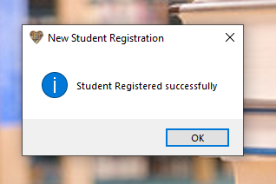

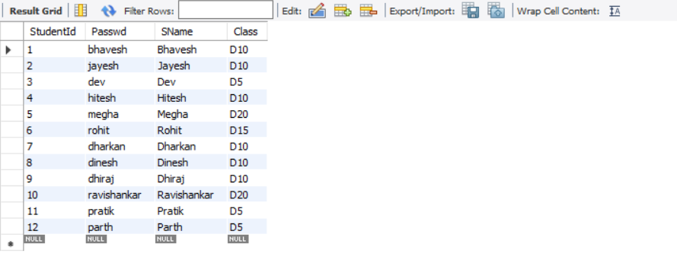

On clicking **LOGOUT** button, the admin is redirected to Main Page



StudentPage.py:

from DefaultPage import *

from tkinter import messagebox

import datetime

class StudentPage(DefaultPage):

def __init__(self, root, student_details):

super().__init__(root)

self.details = student_details

self.root.state('zoomed')

self.dct_StringVar = {}

self.dct_StringVar1 = {}

self.m = self.m = Message(self.f, width=850, font=("Bernard MT Condensed",25,"bold underline"),text=f"Welcome {self.details[2]}\nClass: {self.details[3]}", bg="#b5caeb", relief=SOLID, borderwidth=2)

self.m.place(x=100, y=100)

self.add_buttons()

def add_buttons(self):

self.logout = DefaultPage.CreamButton(self.f, "LOGOUT", self.student_logout, width=10)

self.logout.place(x=1200, y=20)

self.Issue_Books = DefaultPage.CreamButton(self.f, text="ISSUE BOOKS",

command=lambda: self.show_issue_details("<Button-1>"))

self.Issue_Books.place(x=250, y=220)

self.Issue_Books.bind("<Button-1>", self.show_issue_details)

self.book_status_button = DefaultPage.CreamButton(self.f, text="CHECK YOUR PENDING BOOKS", command=self.book_status)

self.book_status_button.place(x=550, y=220)

self.previous_books_button = DefaultPage.CreamButton(self.f, text="VIEW YOUR PREVIOUS BOOKS ", command=self.previous_books)

self.previous_books_button.place(x=850, y=220)

def show_issue_details(self, event):

self.radio_frame = Frame(self.f, bg="#FFDBAC", width=25, height=16)

self.var = StringVar(self.radio_frame, value='0')

self.r1 = Radiobutton(self.radio_frame, text='Sem 1', variable=self.var, value='SEM-I', width=25, height=2, bg="#FFDBAC")

self.r1.grid(row=0,column=0)

self.r2 = Radiobutton(self.radio_frame, text='Sem 2', variable=self.var, value='SEM-II', width=25, height=2, bg="#FFDBAC")

self.r2.grid(row=1,column=0)

self.r3 = Radiobutton(self.radio_frame, text='Sem 3', variable=self.var, value='SEM-III', width=25, height=2, bg="#FFDBAC")

self.r3.grid(row=2,column=0)

self.r4 = Radiobutton(self.radio_frame, text='Sem 4', variable=self.var, value='SEM-IV', width=25, height=2, bg="#FFDBAC")

self.r4.grid(row=3,column=0)

self.r5 = Radiobutton(self.radio_frame, text='Sem 5', variable=self.var, value='SEM-V', width=25, height=2, bg="#FFDBAC")

self.r5.grid(row=4,column=0)

self.r6 = Radiobutton(self.radio_frame, text='Sem 6', variable=self.var, value='SEM-VI', width=25, height=2, bg="#FFDBAC")

self.r6.grid(row=5,column=0)

self.r7 = Radiobutton(self.radio_frame, text='Sem 7', variable=self.var, value='SEM-VII', width=25, height=2, bg="#FFDBAC")

self.r7.grid(row=6,column=0)

self.r8 = Radiobutton(self.radio_frame, text='Sem 8', variable=self.var, value='SEM-VIII', width=25, height=2, bg="#FFDBAC")

self.r8.grid(row=7,column=0)

self.b1 = DefaultPage.CreamButton(self.f, text="SHOW BOOKS", command=lambda: self.show_books(self.var.get()), width=20)

self.b1.place(x=180, y=630)

self.radio_frame.place(x=200, y=300)

def show_books(self, var='SEM-I'):

params = (var,)

query = """select BookId,BName,Author

from project.Book

where Category='%s';"""

result = DefaultPage.DatabaseHelper.get_all_data(query, params)

self.menu_frame = DefaultPage.SimpleTable(self.f, rows=len(result), columns=len(result[0]),

height=400, width=680, colour="#bbdbab")

self.menu_frame.place(x=440, y=300)

self.menu_frame.grid_propagate(0)

for i in range(1, len(result)):

self.dct_StringVar[result[i][0]] = IntVar()

for i in range(len(result)):

for j in range(len(result[0])):

if i == 0:

self.menu_frame.set(row=i, column=j, value=result[i][j], bg="#0aa80c", fg="white")

elif j == 0 and i != 0:

c = Checkbutton(self.menu_frame, text=result[i][j],

variable=self.dct_StringVar.get(result[i][j]))

self.menu_frame.set(row=i, column=j, value=result[i][j], widget=c)

elif j == 1:

self.menu_frame.set(row=i, column=j, value=result[i][j], width=35)

else:

self.menu_frame.set(row=i, column=j, value=result[i][j], width=30)

self.submit = Button(self.menu_frame, text="Issue Book", width=30, height=2, bg="gold", fg="black", command=lambda: self.issue_books())

self.submit.grid(row=len(result) + 2, column=len(result[0]) - 3, rowspan=10)

self.avial_copies = Button(self.menu_frame, text="Check Available Copies", width=30, height=2, bg="gold", fg="black",

command=lambda: self.show_message(self.check_available_copies(self.get_selected_books())))

self.avial_copies.grid(row=len(result) + 2, column=len(result[0]) - 2, rowspan=10)

def issue_books(self):

selected_books = self.get_selected_books()

if len(selected_books) == 0:

messagebox.showwarning("No Book Selected", "Please select one book to Issue")

elif len(selected_books) > 1:

messagebox.showwarning("Many books", "Please do not select more than one book to Issue")

else:

for book_id in selected_books:

no_of_copies = self.check_available_copies(book_id)

if no_of_copies == 0:

messagebox.showinfo('No book','We are Sorry, the book you are looking for is unavailable at the moment. Please try again later.')

break

else:

response = messagebox.askyesno('Confirm issue','Confirm your Book Issue')

if response: # If the answer was "Yes" response is True

self.let_student_issue(selected_books)

else: # If the answer was "No" response is False

self.show_books(self.var.get())

def let_student_issue(self, selected_books):

for book_id in selected_books:

params = (self.details[0], book_id, datetime.datetime.today().date())

query = """insert into project.Lending(SId,BId,BDate)

values('%s','%s','%s');"""

DefaultPage.DatabaseHelper.execute_query(query, params)

params = (book_id,)

query = """update book set AvailableCopies=AvailableCopies-1 where BookId=%s;"""

DefaultPage.DatabaseHelper.execute_query(query, params)

for key, value in self.dct_StringVar.items():

if value.get() == 1:

self.dct_StringVar[key].set(0)

messagebox.showinfo('Book Issued', 'Congratulations!! Book have been Issued to you')

self.show_books(self.var.get())

def get_selected_books(self):

selected_books = []

for key, value in self.dct_StringVar.items():

if value.get() == 1:

selected_books.append(key)

return selected_books

def check_available_copies(self, book_id):

if len(self.get_selected_books()) == 0:

pass

elif len(self.get_selected_books()) > 1:

messagebox.showwarning('Many books', 'Please do not select more than one book')

else:

if type(book_id) == list:

if len(book_id) == 0:

return

else:

book_id = book_id[0]

params = (book_id,)

query = """select AvailableCopies from project.Book where BookId='%s'"""

result = DefaultPage.DatabaseHelper.get_data(query, params)

return result[0]

def show_message(self,copies):

if len(self.get_selected_books()) == 0:

messagebox.showwarning('No Book Selected', 'Please select a book from the list')

elif copies is None:

pass

else :

messagebox.showinfo('Book Count', f'Available copies of Selected book are {copies}')

def book_status(self):

params = (self.details[0],)

query = """select l.OrderId,b.BookId,b.BName,b.Author,l.BDate

from lending l inner join book b

on b.BookId=l.BId

where isReturned=0 and l.SId=%s;"""

result = DefaultPage.DatabaseHelper.get_all_data(query, params)

self.book_status_table = DefaultPage.SimpleTable(self.f, rows=len(result), columns=len(result[0]), width=680, height=400,

colour="#f06787")

self.book_status_table.grid_propagate(0)

self.book_status_table.place(x=440, y=300)

for i in range(1, len(result)):

self.dct_StringVar1[result[i][0]] = IntVar()

for i in range(len(result)):

for j in range(len(result[0])):

if i == 0:

self.book_status_table.set(row=i, column=j, value=result[i][j], bg="#c9083f", fg="white")

elif j == 0 and i!=0:

c = Checkbutton(self.book_status_table, text=result[i][j],

variable=self.dct_StringVar1.get(result[i][j]))

self.book_status_table.set(row=i, column=j, value=result[i][j], widget=c, width=6)

elif j == 2:

self.book_status_table.set(row=i, column=j, value=result[i][j], width=32)

elif j == 3:

self.book_status_table.set(row=i, column=j, value=result[i][j], width=30)

elif j == 4:

self.book_status_table.set(row=i, column=j, value=result[i][j], width=12)

else:

self.book_status_table.set(row=i, column=j, value=result[i][j], width=10)

self.submit = Button(self.book_status_table, text="Return Book", width=30, height=2, bg="gold", fg="black",

command=lambda: self.return_books(self.get_selected_books_status()))

self.submit.grid(row=len(result) + 2, column=len(result[0]) - 3)

self.fine = Button(self.book_status_table, text="Check Fine", width=30, height=2, bg="gold", fg="black",

command=lambda: self.fine_message(self.check_fine(self.get_selected_books_status())))

self.fine.grid(row=len(result) + 2, column=len(result[0]) - 2)

def return_books(self, selected_books):

if len(selected_books) == 0:

messagebox.showwarning('No Book Selected','Please select a book from the list')

elif len(self.get_selected_books_status()) > 1:

messagebox.showwarning('Many books', 'Please do not select more than one book')

else:

fine = self.check_fine(selected_books)

response = messagebox.askyesno('Return Confirmation',f'Please click Yes to proceed. Your Fine is {fine}')

if response: # If the answer was "Yes" response is True

if len(selected_books) == 0:

messagebox.showwarning('No selected book','Please select a book to continue')

else:

params = (datetime.datetime.today().date(), fine, selected_books[0])

query = """update project.Lending

set RDate='%s', Fine='%s', IsReturned=1

where OrderId='%s'"""

DefaultPage.DatabaseHelper.execute_query(query, params)

params = (selected_books[0],)

query = """update book set AvailableCopies=AvailableCopies+1

where BookId=

(select BId from Lending where OrderId=%s);"""

DefaultPage.DatabaseHelper.execute_query(query, params)

messagebox.showinfo('Succesfully book Returned', f'Book Returned. Thankyou')

for key, value in self.dct_StringVar1.items():

if value.get() == 1:

self.dct_StringVar1[key].set(0)

self.book_status()

else: # If the answer was "No" response is False

self.book_status()

def fine_message(self,fine):

if len(self.get_selected_books_status()) == 0:

messagebox.showwarning('No Book Selected','Please select a book from the list')

elif fine is None:

pass

else:

messagebox.showinfo('Book Fine',f'Your Applicable Fine is Rs.{fine}')

def get_selected_books_status(self):

selected_books = []

for key, value in self.dct_StringVar1.items():

if value.get() == 1:

selected_books.append(key)

return selected_books

def check_fine(self,order_id):

if len(self.get_selected_books_status()) == 0:

pass

elif len(self.get_selected_books_status()) > 1:

messagebox.showwarning('Many books', 'Please do not select more than one book')

else:

if type(order_id) == list:

if len(order_id) == 0:

return

else:

order_id = order_id[0]

params = (order_id,)

query = """select BDate from project.Lending where OrderId='%s'"""

result = DefaultPage.DatabaseHelper.get_data(query, params)

borrowDate = result[0]

returnDate = datetime.datetime.today().date()

days = (returnDate - borrowDate).days

# According to Rs.2 per day fine applicable after a week

if days > 7:

fine = 2 * (days - 7)

else:

fine = 0

return fine

def previous_books(self):

query = """Select BName, Author,BDate,RDate,Fine

from Book b join Lending l

on b.BookId=l.BId

where l.IsReturned=1 and l.SId='%d'

order by OrderId DESC"""

parameters = (self.details[0])

result = DefaultPage.DatabaseHelper.get_all_data(query, parameters)

self.recent_orders_table = DefaultPage.SimpleTable(self.f, rows=len(result), columns=len(result[0]), width=680,

height=400,colour="#bbdbab")

self.recent_orders_table.grid_propagate(0)

self.recent_orders_table.place(x=440, y=300)

for i in range(len(result)):

for j in range(len(result[0])):

if i == 0:

self.recent_orders_table.set(row=i, column=j, value=result[i][j], bg="#0aa80c", fg="white")

elif j == 0:

self.recent_orders_table.set(row=i, column=j, value=result[i][j], width=40)

elif j == 1:

self.recent_orders_table.set(row=i, column=j, value=result[i][j], width=25)

else:

self.recent_orders_table.set(row=i, column=j, value=result[i][j], width=10)

def student_logout(self):

import MainPage

messagebox.showinfo('Logout', 'Thank You. We hope to see you again')

self.f.destroy()

self.panel.destroy()

self.redirect = MainPage.MainPage(self.root)

if __name__ == '__main__':

root = Tk()

c = StudentPage(root, (6, 'rohit', 'Rohit', 'D15'))

root.mainloop()

**OUTPUT:**

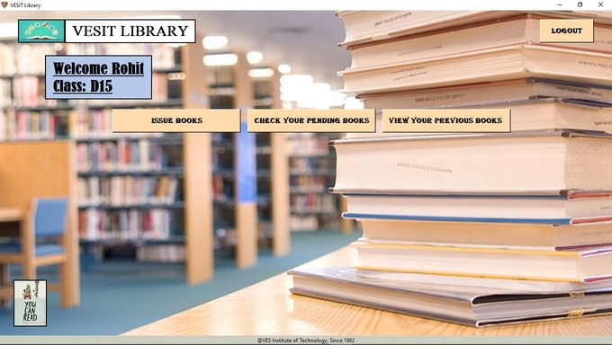

On clicking **ISSUE BOOKS** button:

The buttons for all semesters and **SHOW BOOKS** button will appear.

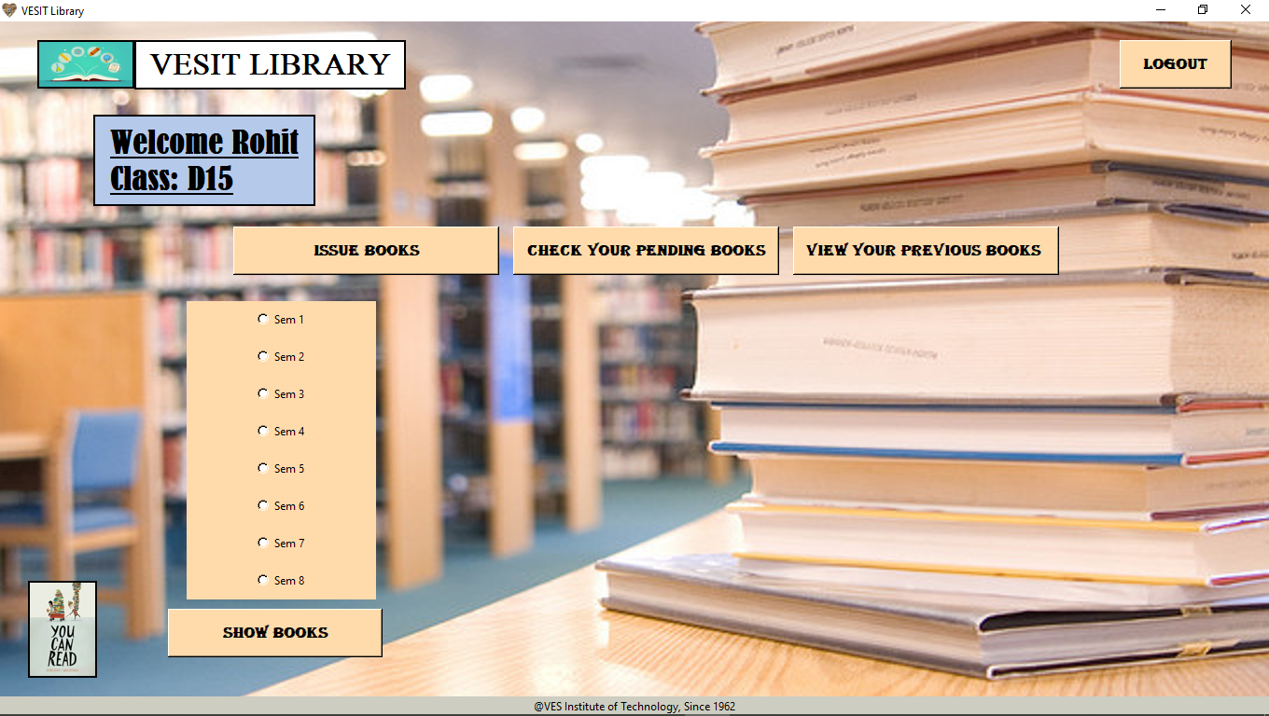

On Selecting Semester and clicking on **SHOW BOOKS:**

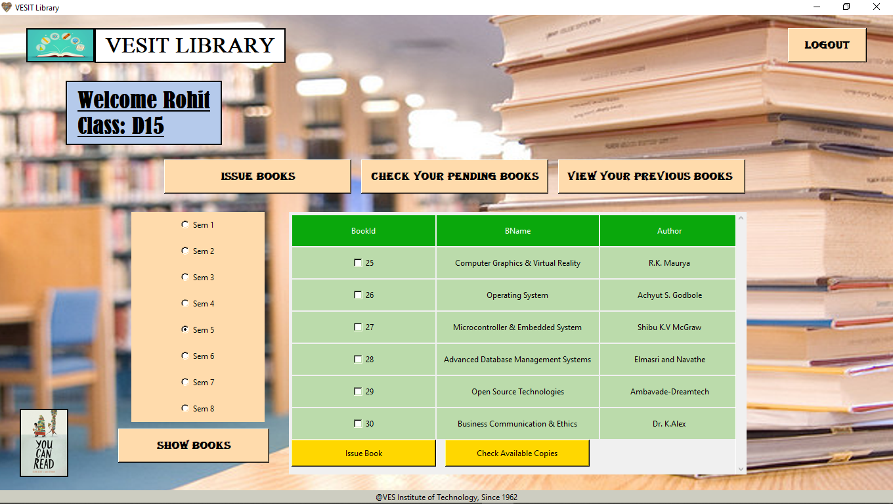

If clicked **ISSUE BOOK** without selecting a option, a warning message will popup:

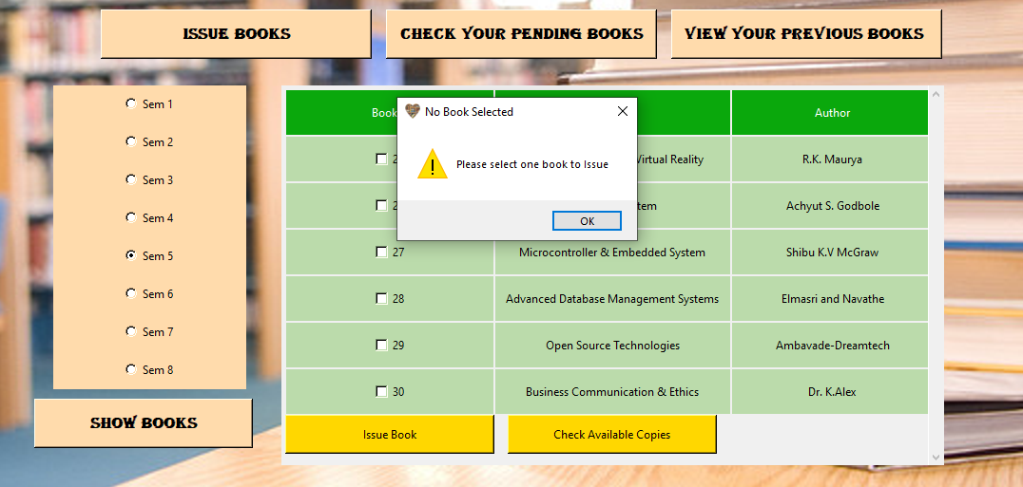

If selected more than one book at a time, the warning message will popup:

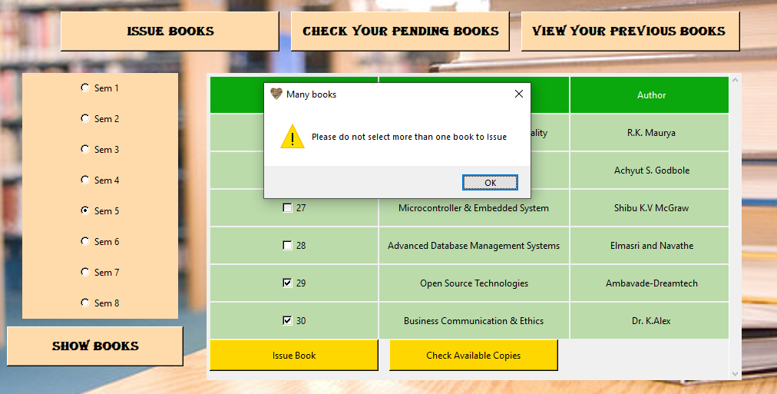

When Student selects a book and clicks on **ISSUE BOOK:**

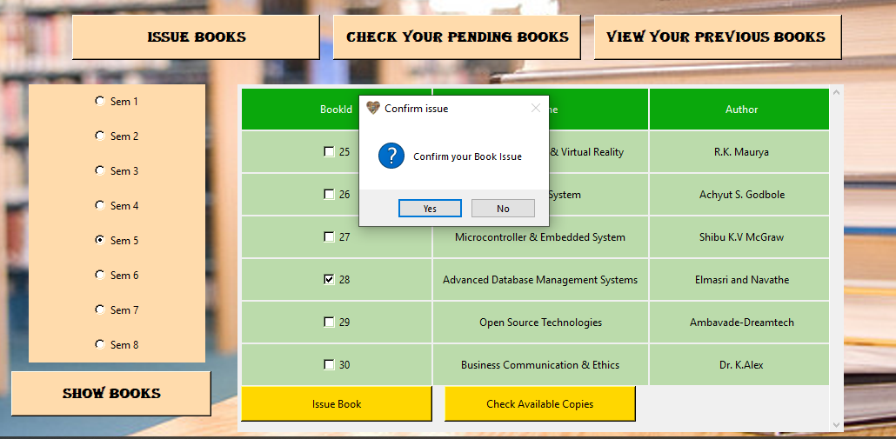

On clicking **NO** in the confirmation window, the selected option will be deselected and the options appear again

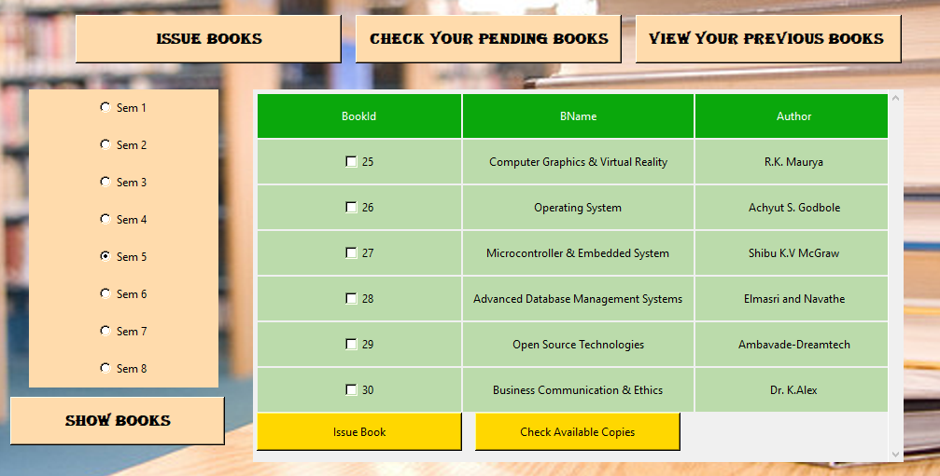

On clicking **YES** in the above confirmation window, the book is Issued to the student

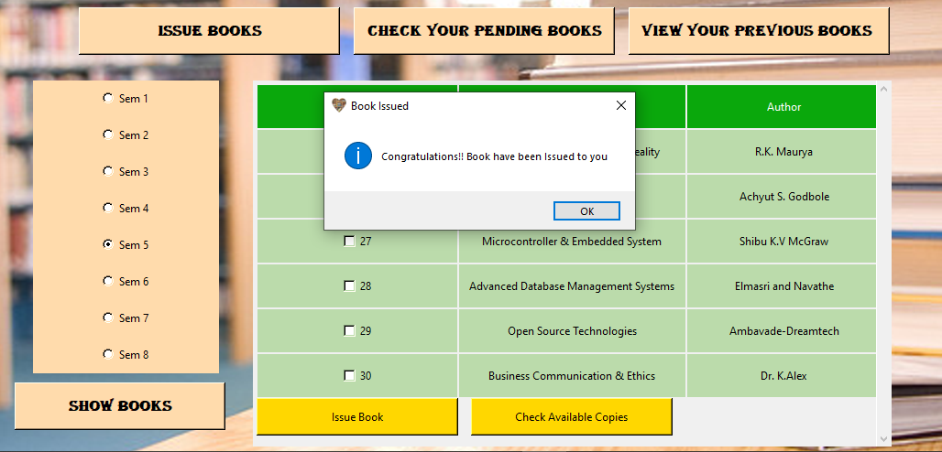

The Issued book is entered in Lending table in database

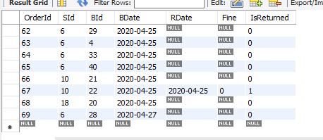

On selecting a option and clicking on **CHECK AVAILABLE COPIES**, the available copies are displayed in messagebox

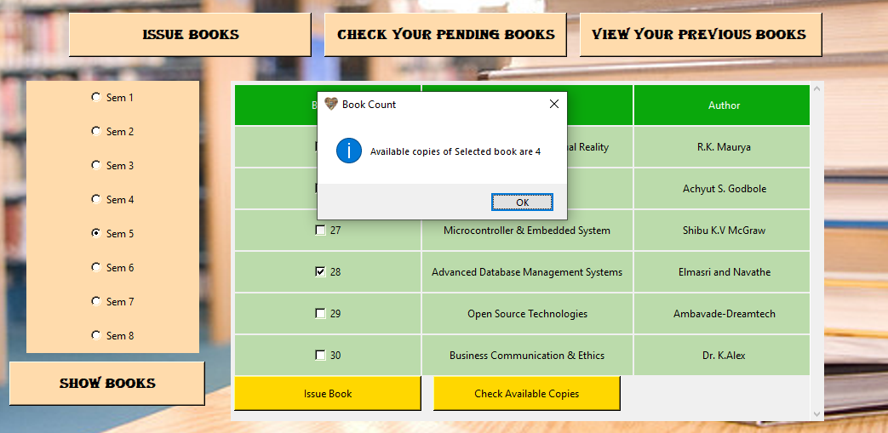

On clicking **CHECK YOUR PENDING BOOKS,** the list of books student has ordered but has not returned.

This list also contains checkboxes and same validations as seen while **ISSUE BOOK,** when student clicks on the **RETURN BOOK** or **CHECK FINE** buttons below the list.

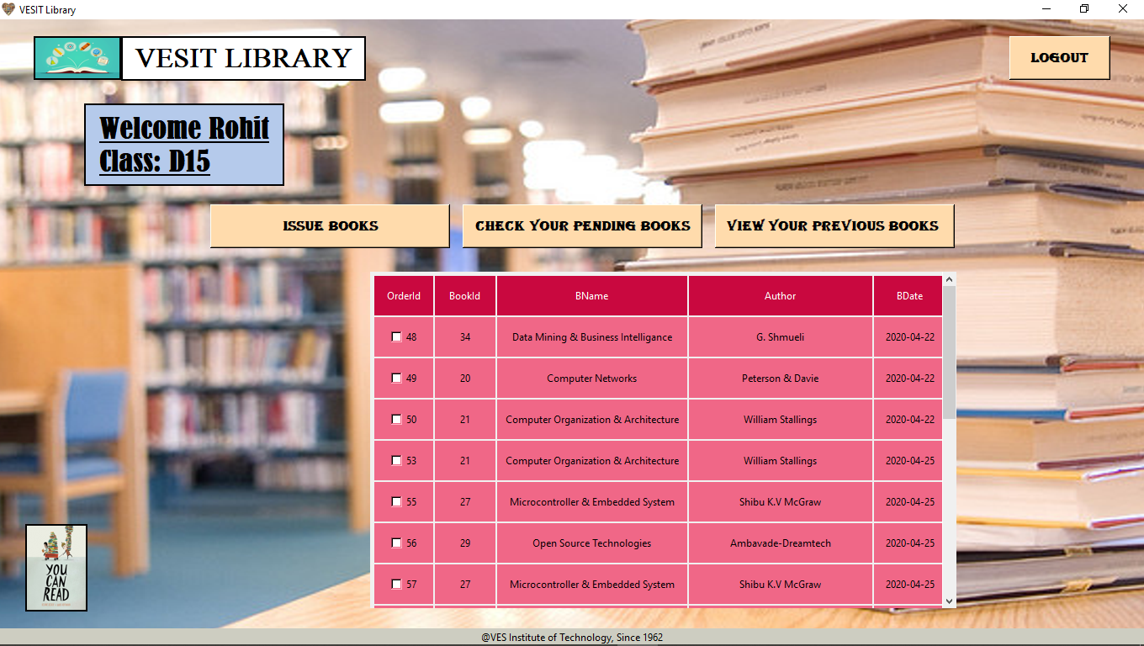

On clicking **CHECK FINE** button student can see his/her fine for a particular issued book

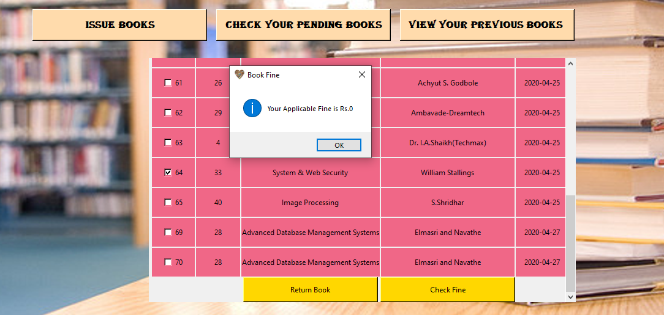

On selecting the book and returning it by **RETURN BOOK** button, a confirmation window will popup

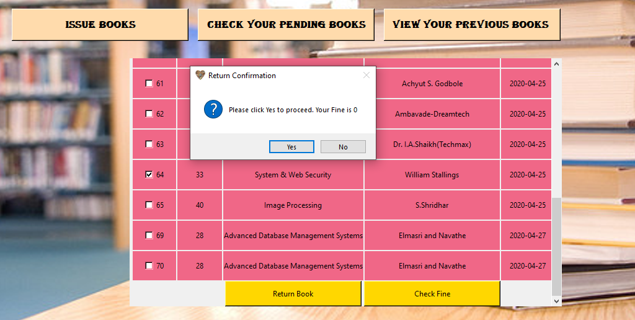

On clicking **NO** the list will again appear and the selected option will be deselected

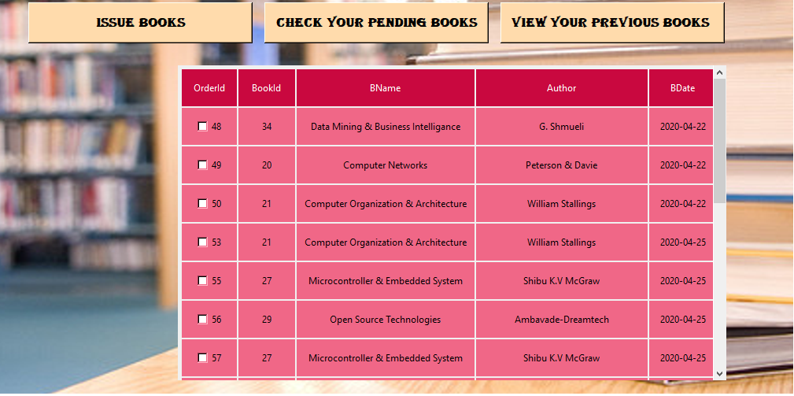

On clicking **YES** the book will be returned

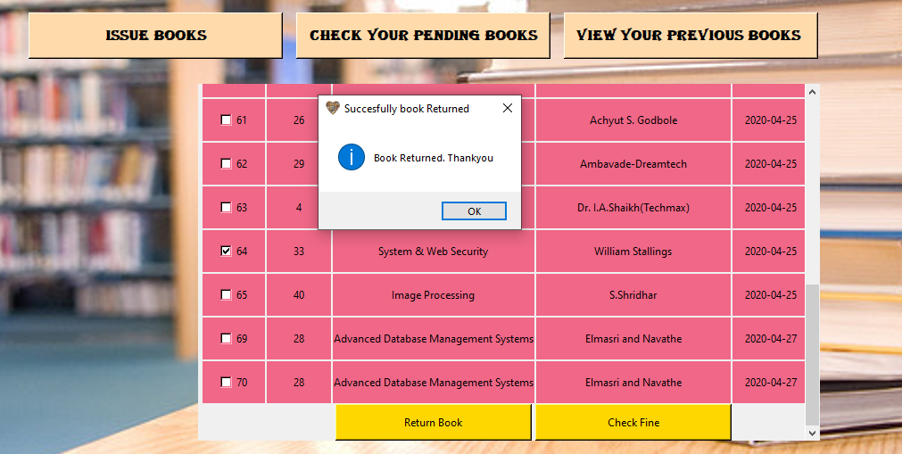

On clicking **YES** the book will be returned, as isReturned is 1 in database after return, here book of OrderId of 64 has returned book

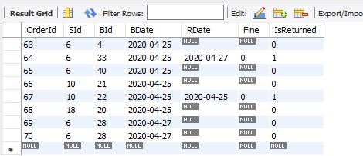

On clicking **VIEW YOUR PREVIOUS BOOKS,** student can view his/her previously returned books

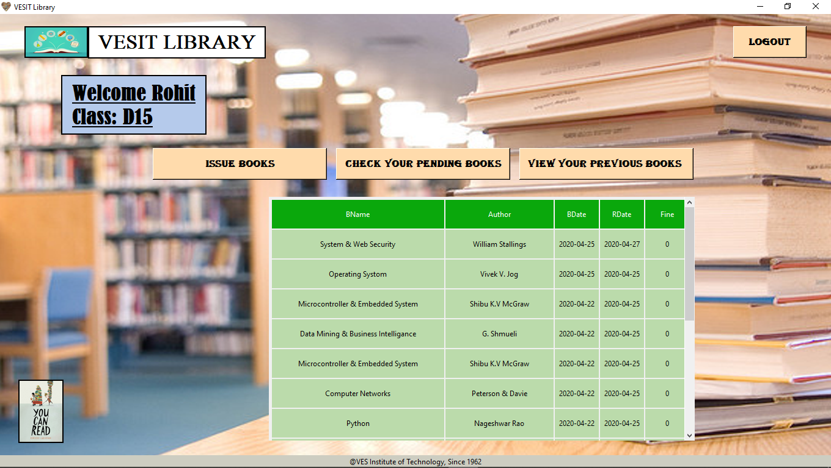

On click of **LOGOUT** button a short message is displayed and student is redirected to main page

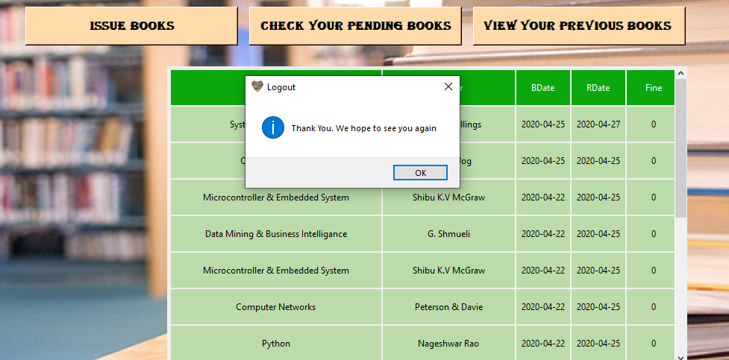



**CONCLUSION:**

We conclude the project by assuring that we learnt many concepts of tkinter and mysql.